**Mathematical expression for simple graph**

Graph of Ferris Wheel is composed of the simple functional graphs such as lines and circles. In this way, we need to determine the expressions of these circles and lines, and their perimeters. The structure of the Ferris Wheel, “The London Eye”1, can be roughly drafted as mathematical functional figures shown in Fig.1. The cars are referred to as outer circles; the frame is referred to as inner circles and inner lines; and the pedestal is referred to as stanchion lines.

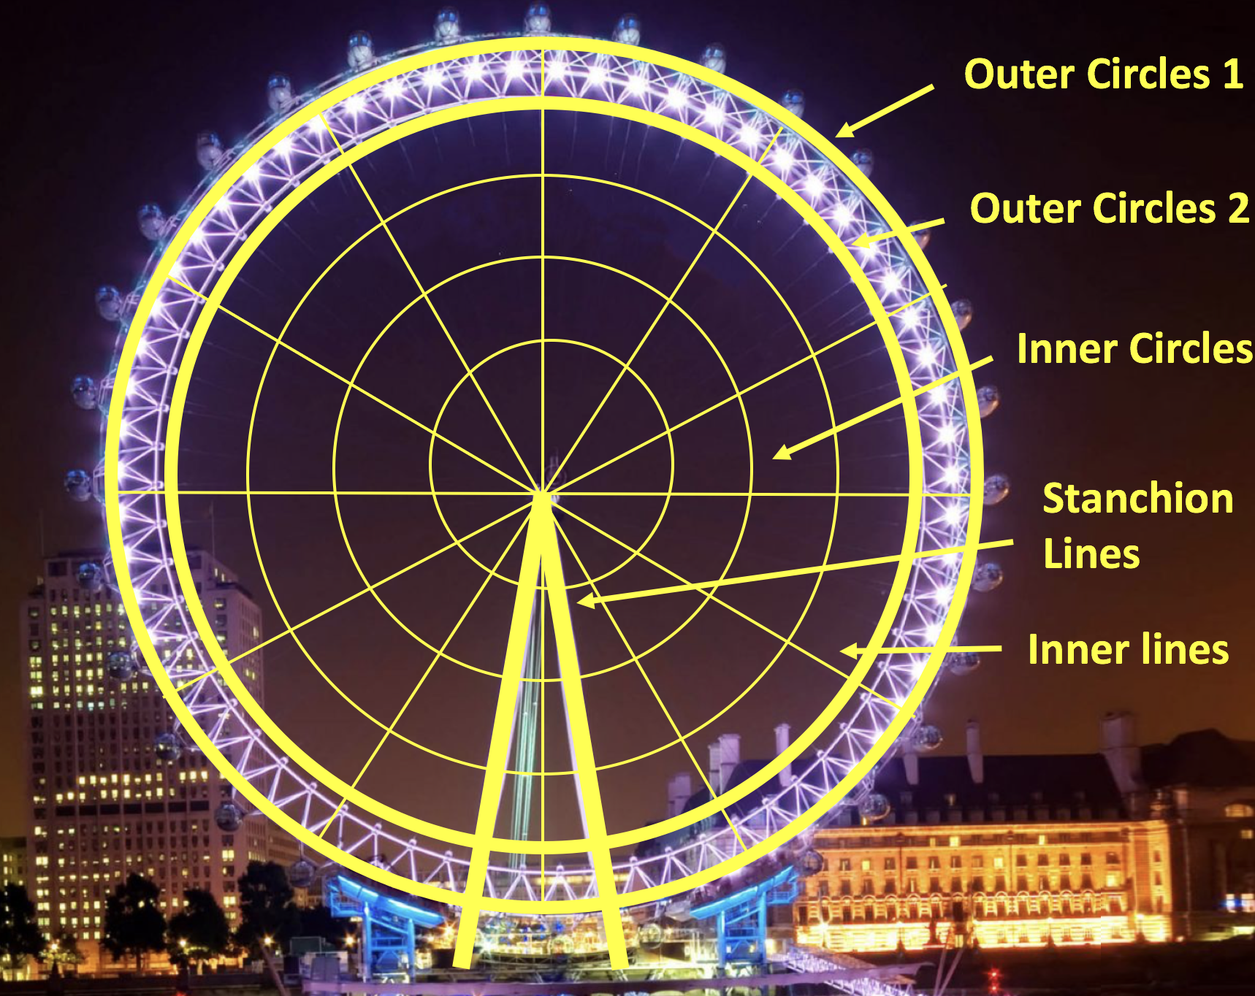

*Fig.1 functional expression of The London Eye*

Assume that the center of circles is origin. And *RC1, RC2* are the radii of two outer circles, and *C*1*, C*2are represented as the perimeter of the outer circles. The parametric equation of the inner circles is shown following,

$\left\{\begin{aligned}x=\sin\left(\frac{2π}{t}∙m\right)∙\frac{i}{n+1}{∙R}_{1} \\ \\ y=\cos\left(\frac{2π}{t}∙m\right)∙\frac{i}{n+1} {∙R}_{1}\end{aligned}\right.$

$$\left\{\begin{aligned} m=1, 2, 3,…, t \\ i=1,2,3,…, n\end{aligned}\right.$$

where *x* and *y* are the coordinates of every point at the inner circles; t is the number of drones in one inner circle; and n is number of circles inside. By joining the points in one line which passes through the origin, the inner lines could be derived. And the expression of stanchion line could be estimated as a linear function which could by estimating the slope (the slant angle of the pedestal mostly is around 15 $°$) according to the reality. And comparing with the most Ferris Wheels’ pictures, it can be measured that the ratio between *RC1* and *RC2* is nearly 1.1 (such as for The London Eye, the ratio is 135: 122 = 1.1062). By using the MATLAB, the distribution graph of the drone swarm could be realized, shown in Fig.2 following, which the larger points represent the higher brightness.

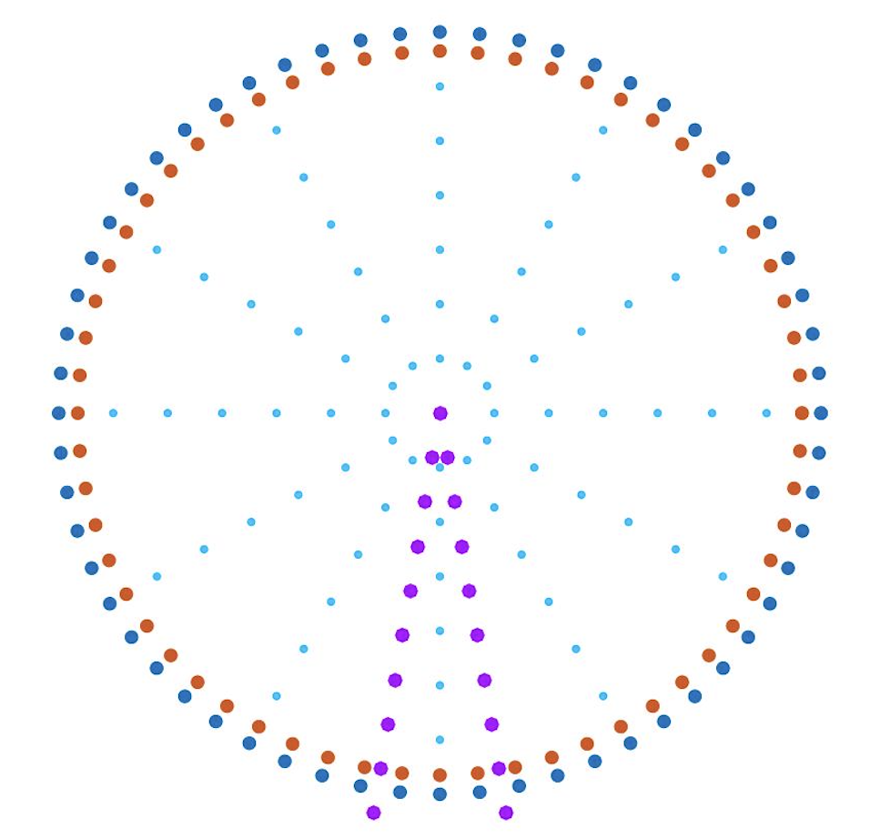

*Fig.2 Ferris Wheel Plan*

In addition, the amount of drones and their distribution can be obtained by parameterization. Assume that the numbers of drones at each inner circles are N*1*, N*2*, N*3*, … N*i* and the radii of each circle are R*1*, R*2*, R*3*, … R*i*, respectively. Defining the drones’ density:

$$ρ=\frac{N_{i}}{R_{i}}$$

From the deeper research, errors caused by GPS positioning lead to the minimum safe distance between two normal drones that is around 3 to 5 meters. Thus, every two points in the functional graph should be less than this distance.

When in the real performance, the drone swarms are flied in three dimension. But the movement of each drone is in one dimension. So for every performance pattern, first we could draw the 2-D mathematical image, then slope it in an angle which could enjoy the spectators best (specifically illustrate at 2.1). Assuming the view angle is $30°$, the MATLAB simulates the image shown in Fig. 3. a & b.

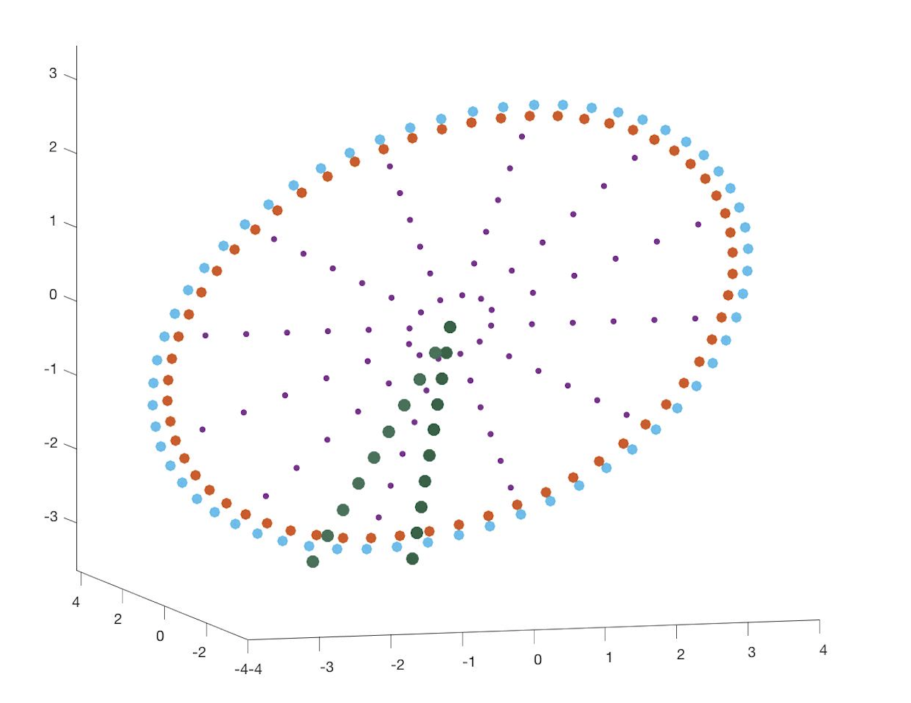

*a. Ferris Wheel in 3-D*

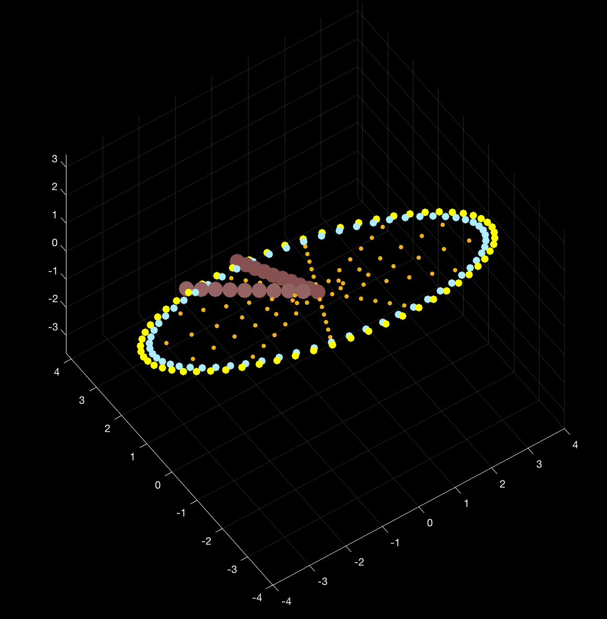

*b. top view of design sketch*

*Fig.3 a. & b. show the Ferris-Wheel-shaped function realized in 3-D*

The cost and the aesthetics are also the significant consideration of designing. The less drones with more beauty, the better design it is. By changing the number of drones in the outer circles and in the pedestals, we could make trade-off. Several comparison diagrams are shown in Fig.4:



*Fig. 4 different numbers of drones in Outer Circles and Pedestals*

The second scheme is what we recommend: forty drones in each outer circles, twelve drones in each inner circles, nine drones for each pedestal, thirty degrees for the slant angle of two pedestal, and thirty degrees for the angle of inclination in three dimension.



$$\begin{matrix}P_{11} & ... & P_{1n} \\ ⋮ & P_{ij} & ⋮ \\ P_{m1} & ... & P_{mn}\end{matrix}$$

1. If $P_{ij}$ = 0,

$D_{ij}$ = 0

1. If $P_{ij}$ = 1, and $∀\left(P_{\left(i-1\right)j}=0;P_{\left(i+1\right)j}=0; P_{i\left(j-1\right)}=0; P_{i\left(j+1\right)}=0\right)$,

$D_{ij}$ = 0

1. If $P_{ij}$ = 1, and $∃\left(P_{\left(i-1\right)j}=0;P_{\left(i+1\right)j}=0; P_{i\left(j-1\right)}=0; P_{i\left(j+1\right)}=0\right)$,

$D_{ij}$ = 1

*Reference*

*1.* *https://www.duitang.com/blog/?id=477001999*

*2.* [*https://wenku.baidu.com/view/f855190003d8ce2f006623db.html*](https://wenku.baidu.com/view/f855190003d8ce2f006623db.html)

*Appendix*

% 2-D Ferris Wheel

alpha=0:pi/30:2*pi;

R=2;

x=R*cos(alpha);

y=R*sin(alpha);

plot(x,y,'.','MarkerSize',20)

axis equal

hold on

alpha=0:pi/30:2*pi;

R=1.9;

x=R*cos(alpha);

y=R*sin(alpha);

plot(x,y,'.','MarkerSize',20)

axis equal

m=1:12;

x0=[];

y0=[];

for i=1:6

x=sin(2*pi/12*m)*i*2/7;

y=cos(2*pi/12*m)*i*2/7;

x0=[x0 x];

y0=[y0 y];

end

plot(x0,y0,'.','color',[0 191 255]/255,'MarkerSize',12)

XY=[x0;y0]';

hold on

x = linspace (-0.35,0,10) ;

y = 6*x ;

plot (x,y,'.','color',[2/3 0 1],'MarkerSize',25) ;

hold on

x = linspace (0,0.35,10) ;

y= -6*x ;

plot (x,y,'.','color',[2/3 0 1],'MarkerSize',25) ;

hold on

x=0;y=0;plot(x,y,'MarkerSize',50)

% 3-D Ferris Wheel

alpha=0:pi/30:2*pi;

R=2;

x=R*cos(alpha);

y=R*sin(alpha);

x0=2*x;

y0=-y*2;

z0=-0.5*y0*3.^0.5;

plot3(x0,y0,z0,'.','MarkerSize',25)

axis equal

hold on

alpha=0:pi/30:2*pi;

R=1.9;

x=R*cos(alpha);

y=R*sin(alpha);

x0=2*x;

y0=-y*2;

z0=-0.5*y0*3.^0.5;

plot3(x0,y0,z0,'.','MarkerSize',25)

axis equal

hold on

m=1:12;

x0=[];

y0=[];

for i=1:6

x=sin(2*pi/12*m)*i*2/7;

y=cos(2*pi/12*m)*i*2/7;

x0=[x0 x];

y0=[y0 y];

end

y0=-y0*2;

z0=-0.5*y0*3.^0.5;

plot3(2*x0,y0,z0,'.','MarkerSize',12)

hold on

x = linspace (-0.35,0,10) ;

y = 6*x;

y0=-y*2;

x0=2*x;

z0=-0.5*y0*3.^0.5;

plot3(x0,y0,z0,'.','MarkerSize',30)

hold on

x = linspace (0,0.35,10) ;

y= -6*x ;

y0=-y*2;

x0=2*x;

z0=-0.5*y0*3.^0.5;

plot3(x0,y0,z0,'.','MarkerSize',30);

hold on

% parameterization

n1=36; %number of drones in outer circles

n2=11; %in pedestal

m=1:12; %numbers of lines inside

n=6;% drones in each line

n3=5% numbers of bearing

% two pedestal

xxx=[];

yyy=[];

x = linspace (0,0.35,2*n2) ;

y= -6*x ;

y0=-y;

z0=-2*y0/3.^0.5+0.1;

plot3(x,y0,z0,'.','MarkerSize',30);

xxx=[xxx x];

yyy=[yyy y0];

hold on

x = linspace (-0.35,0,2*n2) ;

y= 6*x ;

y0=-y;

z0=-2*y0/3.^0.5+0.1;

plot3(x,y0,z0,'.','MarkerSize',30);

xxx=[xxx x];

yyy=[yyy y0];

hold on

%Circle

alpha=linspace(0,2*pi,n1);

R=2;

x=R*cos(alpha);

y=R*sin(alpha);

y0=-y;

z0=-2*y0/3.^0.5;

plot3(x,y0,z0,'.','MarkerSize',25)

axis equal

xxx=[xxx x];

yyy=[yyy y0];

hold on

% inside lines

x0=[];

y0=[];

for i=1:n

x=sin(2*pi/12*m)*i*2/7;

y=cos(2*pi/12*m)*i*2/7;

x0=[x0 x];

y0=[y0 y];

end

y0=-y0;

z0=-2*y0/3.^0.5;

plot3(x0,y0,z0,'.','MarkerSize',12)

xxx=[xxx x0];

yyy=[yyy y0];

hold on

% inside circle

alpha=linspace(0,2*pi,n1);

R=1.9;

x=R*cos(alpha);

y=R*sin(alpha);

y0=-y;

z0=-2*y0/3.^0.5;

plot3(x,y0,z0,'.','MarkerSize',25)

axis equal

xxx=[xxx x];

yyy=[yyy y0];

hold on

% code of drwa complicated graph

clear

clc

A=imread('111.png');

A(find(A<150))=1;

A(find(A>=150))=0;

A=double(A);

A=A(:,:,1);

%imshow(A)

[x,y]=size(A);

B=zeros(x,y);

for i=2:x-1;

for j=2:y-1;

if A(i+1,j)==0 | A(i-1,j)==0 | A(i,j+1)==0 | A(i,j-1)==0

%if A(i+1,j)+A(i-1,j)+A(i,j+1)+A(i,j-1)<3

B(i,j)=1;

end

if A(i,j)==0;

B(i,j)=0;

end

end

end

%imshow(B)

n=sum(sum(B));

zero=find(B(1,:)==1);

zero=zero';

[sizex sizey]=size(zero);

zero_indexs=[ones(sizex,1) zero];

for i=2:x

zero=find(B(i,:)==1);

zero=zero';

[sizex sizey]=size(zero);

zero_indexs=[zero_indexs;i*ones(sizex,1) zero];

end

distance=zeros(n,n);

for i=1:n

for j=1:n

x0=zero_indexs(i,1)-zero_indexs(j,1);

y0=zero_indexs(i,2)-zero_indexs(j,2);

distance(i,j)=x0^2+y0^2;

end

end

distance=distance+eye(n,n)*max(max(distance));

zero_xin=ones(n,2);

zero_xin(1,:)=zero_indexs(1,:);

ymin=1;

for i=2:n

Dis=distance(ymin,:);

[xmin yminmin]=find(Dis==min(min(Dis)));

distance(ymin,:)=max(max(distance));

distance(:,ymin)=max(max(distance));

ymin=yminmin(1,1);

zero_xin(i,:)=zero_indexs(ymin,:);

end

shumu=500;

bianhao=linspace(1,n,shumu);

bianhao=round(bianhao);

zero_xinxin=zero_xin(bianhao,:);

tu=zero_xinxin;

plot(tu(:,1),tu(:,2))

C=zeros(x,y);

for i=1:shumu

qwe=tu(i,1);

ewq=tu(i,2);

C(qwe,ewq)=1;

end

imshow(C)